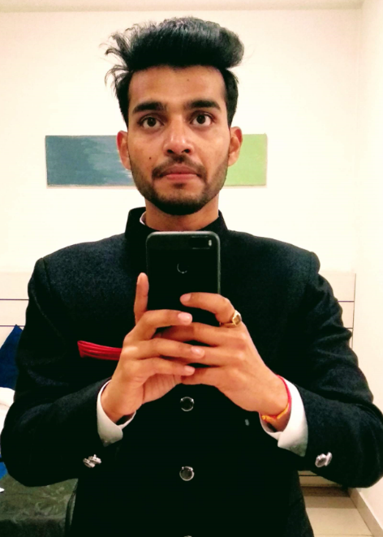

**About Me**

* **DOB :17/06/1992**
* **Time: 23:05**
* **Place of Birth: Bareilly**
* **Caste: Hindu – Baniya (Agarwal)**
* **Job Designation: Sr Systems Management Analyst at UnitedHealth Group, Noida**
* **Height- 5 ft 7 inch(169cms)**
* **Weight – 70 Kgs**
* **Education Details:**
  + **B.Tech in ECE from Lovely Professional University, Jalandhar(Punjab)**
  + **12th from Birla Sr. Secondary School, Pilani (Rajasthan)**
  + **10TH from GD Birla Memorial School, Ranikhet**
* **Liberal thinking and Modern Beliefs**
* **Eggetarian**
* **Hobbies: Travelling/Trekking, Reading Blogs, Web Series**

**Grand Father:** Late Dr Surendra Prakash Agarwal (ABMS)

**Grand Mother:** Late Mrs. Urmila Agarwal

**Father** : Dr Alok Kumar Agarwal

Doctor (BAMS)

**Mother**: Mrs. Reeta Agarwal

Housewife

**Brother**: Kunal Agarwal

B.tech(CSE), Preparing for UPSC CSE

**Sister**: Nikita Agarwal

Pursuing BEd , Teaching Primary Classes.

I am a simple and down to earth person having positive outlook towards life. I will be there for you in ups and downs of life.

I respect elders and have a giving attitude towards society. I am a kind of a person who believes in constructive activities. I believe in mutual respect in a relationship and will support my partner in pursuing their interests**.**

I am open to pets and would love to adopt.

**Expectations**

**Family Details**

Looking for a person with matching vibes and understanding. She should have respect for elders and should be committed towards marriage. I prefer a person who would continue their job and will want to excel in their field.